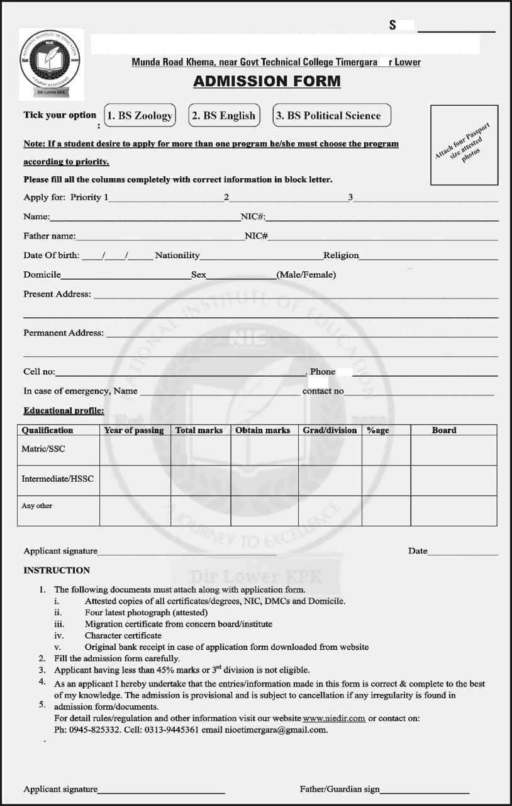
.No
NATIONAL INSTITUTE OF EDUCATION
Di
www.nie.edu.pk
ADMISSON FORM FOR BS PROGRAME

